**Working Title: The Black Samurai.**

**Concept:**

A fast paced action game that picks up speed and intensity with progression.Player controls a sword wielding samurai a fight to free Japan from the rule of a tyrant emperor. Gameplay will consist of a combination of elements from older side scrolling platform games.

**Storyline / Game Box Blurb.**

You are the Black Samurai. A once honourable warrior turned assassin, selling his skills to the highest bidder. You have gone down the dark path for too long and seek to regain your honour. Compelled by moral conflict you turn on your employers to defend the victims of a tyrant’s ambition.

* Fast paced sword fighting action with a unique control scheme.
* Characters speed/power relies on interactions with the game world physics.
* Find you own fighting style to defeat an entire army!

**Genre and Inspirations.**

Primarily an Action/adventure platform/indie game. This game would specifically be classed as a side scrolling beat’em’up. Originally Inspired by Double Dragon 3 (Super Nintendo) with physics elements similar to Sonic the Hedgehog (Sega) where the player can pick up speed down hills to jump higher,/further to reach harder to get platforms.

**Target Audience and Platform Deployment.**

Designed to be easily picked up by anyone this game is targeted at a large variety of ages and backgrounds. The casual gamer that likes to jump right into some action without having to get to heavily involved. This is a violent game so will likely to attract males of between the ages of 13 and 25. The older experienced gamers will also be attracted as it will provide some nostalgic resemblance to the classic platform games they grew up with.

Initially the target platform will be windows/steam and mac. Android IOS and console versions of the game will be released after feedback is received from desktop users.

**Treatment (why should you fund this games development.)**

This game brings back the old element of playing for the fun of the interacting with the game itself rather than relying on cheap tricks to hold the players interest. The current market is flooded with games that use achievements levelling systems and other tactics to keep the players involved. This game will attract the growing number of customers that are tired of these tactics and are looking for a fresh outlook on the original elements that attracted them to gaming in the first place. With the mechanics and control scheme design players will be feel they are developing a skill that they can brag about. Further sales attraction will accumulate with the conversation and competitive bragging to friends about how fast and skilful they are in this game. Directing the focus to an internal satisfaction rather than the external obsessive collecting and levelling elements that the gaming community is growing tired of.

**Game mechanics.**

Similar to Double Dragon series it will involve the camera following the character through levels containing lots of enemies that the player must defeat with melee attacks. Double Dragon 3 was one of the 1st games of its kind to employ a more complicated fighting mechanics were players could grab, flip and thro enemies around using the same button. Similarly timing attack coordination will be a major part of the fight mechanics but are not confined to scripted actions. Level design will have flow similar to Sonic the Hedgehog (Sega Master System), involving multiple platform levels that line up with trajectories that the character can only reach after picking up speed from running down hills. The graphics however will be themed around ancient Japanese landscapes and building.

**Control scheme.**

The controls for the samurai character will consist of 2 sets of X & Y axis controls. One for moving around and jumping and the other for swinging his sword in directions for attacks. Any contact of the sword on objects and enemies will cause damage to health depending a calculation based on the number of changes in sword angle before contact, combined with the characters current speed will determine the amount of damage an attack makes. This is in line with the concept that fun is defined by pressing the boundaries of the limitations your presented with.

This control scheme means that there is no one way of playing the game and provides freedom for players to explore and develop their own playing style within the game world.

**Concept Art.**

Figure 1 show the game cover concept illustrating the overall feel of the game to be a dark and violent one. The game will feature a level design that makes use of the player’s ability to pick up speed to reach various platforms as illustrated in figure 2. Character will be constructed with traditional style samurai outfit with a black finish as shown in Figure 3. Figure 4 show how the control scheme would be used on touchscreen devices. Blue indicates the location of axis controls but would not actually be visible to the player as this would obstruct the player’s vision of the game. 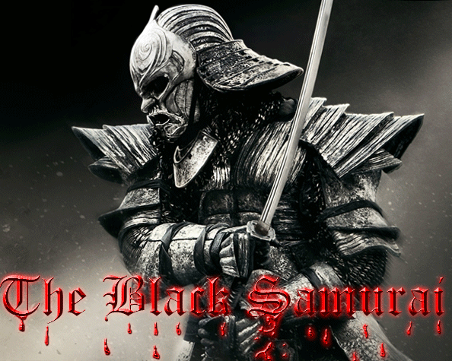Figure 1: Concept for game cover.

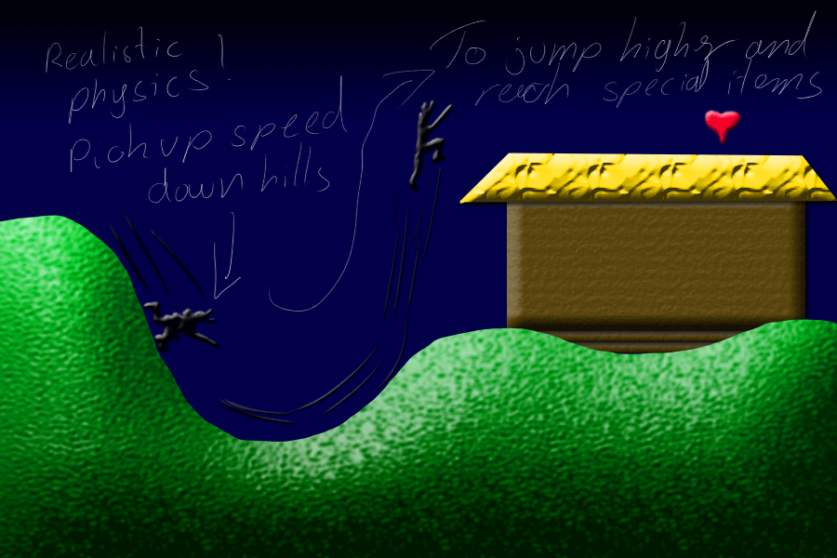  
Figure 2: Physics and level interaction. Pickup speed down hills to reach higher platforms.

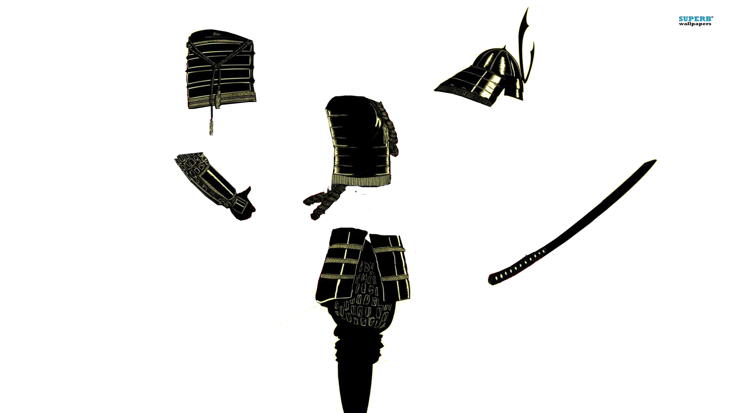

Figure 3: Early character construction for use in game environment.

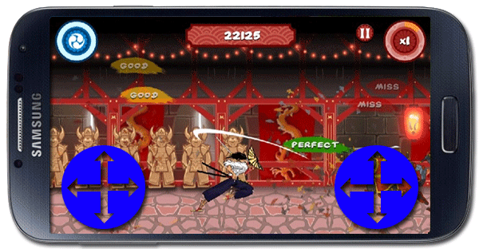

Figure 4: Illustrating how the game would be controlled on touchscreen platforms.

**References: Sources used for concept art.**

<http://artemisdefenseinstitute.com/Blog/3261659>

<http://www.hardcoregamer.com/2012/10/03/playstation-mobile-now-available-on-vita/14775/>

<http://www.gaksdesigns.com/The-Headless-Samurai>

<http://www.history.com/topics/samurai-and-bushido>